Project tittle: Innovative Green Technologies

# Introduction

Innovative Green Technologies (IGT) is a Lebanese medium enterprise that focuses on developing innovative green energy systems to enhance the efficiency and reliability of water, energy, and food sectors. They offer solutions like hybrid solar systems, solar water heating, and solar water pumping.

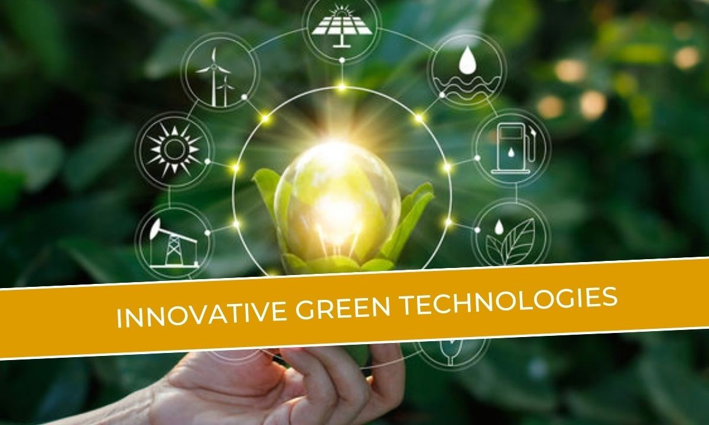

The company operates as a full-service design, build, and decommissioning company for technology infrastructure, providing environmentally friendly solutions in prestigious locations to solve challenging technological problems with innovative, cost-effective, and energy-efficient approaches.

This article aims to explore the transformative power of innovative green technologies and their role in shaping a sustainable future.

# Overview of Green Technologies

The overview of green technologies encompasses a wide array of environmentally friendly solutions aimed at reducing the impact of human activities on the environment.

Green technology, also known as environmental technology, covers various sectors such as renewable energy, water management, recycling, waste management, agriculture, and sustainable industry. Key green technologies include:

* **Solar Energy:** Utilizing solar panels to convert sunlight into electricity, providing a clean and renewable energy source.
* **Wind Energy:** Generating electricity from wind turbines, offering an eco-friendly alternative to fossil fuels.
* **Hydroelectricity:** Producing power from the flow of water, whether from rivers, dams, or tides, as a predictable energy source.
* **Battery Energy Storage:** Storing energy through technologies like anaerobic digestion, which converts organic matter into gas for electricity generation.
* **Recycling:** Reusing materials like aluminum, steel, plastic, and paper to reduce the need for new resources and minimize waste.

These green technologies play a crucial role in reducing greenhouse gas emissions, promoting renewable energy sources, and fostering sustainable practices to protect the environment and create a more sustainable future.

# Need for Innovation in Green Technologies

The need for innovation in green technologies is paramount in addressing the pressing environmental challenges we face today. Here are the key reasons why innovation in green technologies is crucial:

# Mitigating Climate Change:

* + Green technologies, such as renewable energy, energy-efficient systems, and carbon capture solutions, are essential for reducing greenhouse gas emissions and mitigating the impacts of climate change.
  + Continuous innovation in these technologies is necessary to improve their efficiency, affordability, and scalability to drive widespread adoption.

## Reducing Pollution and Environmental Degradation:

* + Green innovations in waste management, water treatment, and sustainable manufacturing can help combat pollution and protect natural ecosystems.
  + Developing new technologies to recycle, reuse, and repurpose waste materials is crucial for transitioning to a more circular economy.

## Preserving Natural Resources:

* + Green technologies that promote resource efficiency, such as renewable energy, water conservation systems, and sustainable agriculture practices, are vital for preserving finite natural resources.
  + Innovative solutions are needed to reduce resource depletion and ensure a sustainable future.

## Achieving Sustainable Development Goals:

* + The United Nations' Sustainable Development Goals (SDGs) emphasize the importance of clean energy, sustainable cities, responsible consumption, and climate action, all of which rely on advancements in green technologies.
  + Innovative green solutions are essential for making progress towards these global sustainability targets.

# Examples of Innovative Green Technologies

* + **Solar Desalination:** Using solar energy to desalinate salt water and provide a sustainable solution to water shortages, desertification, and hunger.
  + **Ocean Energy:** Harnessing the power of waves, tides, salinity gradients, and ocean thermal energy to generate renewable electricity. Companies like OceanEnergy are developing technologies to tap into this vast, untapped energy source.
  + **Green Buildings:** Incorporating eco-friendly materials and energy-efficient designs in construction to reduce environmental impact and energy consumption. This includes technologies like smart insulation, green roofs, and passive solar heating.
  + **Green Vehicles:** Promoting the adoption of electric vehicles to reduce reliance on fossil fuels and lower carbon emissions.
  + **Vertical Farming:** Utilizing controlled indoor environments to grow crops vertically, which can significantly reduce water and land usage compared to traditional farming.
  + **Emissions Treatment:** Developing technologies to manage and treat industrial emissions, such as those from the chemical, petrochemical, and pharmaceutical sectors, to reduce greenhouse gas emissions.
  + **Waste-to-Energy:** Converting waste into usable energy, such as steam, hot water, or electricity, through technologies like incineration and pyrolysis. This helps reduce waste and generate renewable energy.
  + **Recycling and Waste Management:** Implementing advanced technologies for sorting, tracking, and processing waste to promote a more circular economy and reduce environmental impact.
  + **Biofuels:** Producing fuel from the valorization of plastic waste and other organic matter, providing a sustainable alternative to fossil fuels.
  + **Wastewater Treatment:** Advancing technologies like membrane filtration, microbial fuel cells, and nanotechnology to improve the treatment of wastewater and make it reusable.

# Impact of Innovative Green Technologies

the key points regarding the impact of innovative green technologies are:

## Mitigating Climate Change:

* + Green technologies, such as renewable energy, energy-efficient systems, and carbon capture solutions, are essential for reducing greenhouse gas emissions and mitigating the impacts of climate change.
  + Continuous innovation in these technologies is necessary to improve their efficiency, affordability, and scalability to drive widespread adoption.

## Reducing Pollution and Environmental Degradation:

* + Green innovations in waste management, water treatment, and sustainable manufacturing can help combat pollution and protect natural ecosystems.
  + Developing new technologies to recycle, reuse, and repurpose waste materials is crucial for transitioning to a more circular economy.

## Preserving Natural Resources:

* + Green technologies that promote resource efficiency, such as renewable energy, water conservation systems, and sustainable agriculture practices, are vital for preserving finite natural resources.
  + Innovative solutions are needed to reduce resource depletion and ensure a sustainable future.

## Achieving Sustainable Development Goals:

* + The United Nations' Sustainable Development Goals (SDGs) emphasize the importance of clean energy, sustainable cities, responsible consumption, and climate action, all of which rely on advancements in green technologies.
  + Innovative green solutions are essential for making progress towards these global sustainability targets.

# Future Trends in Green Technology Innovation

Future trends in green technology innovation are poised to shape a more sustainable and environmentally conscious future. Some emerging trends include:

* + **Circular Economy:** Emphasizing the reuse, repair, and recycling of materials to reduce waste and maximize resource value, promoting a more sustainable approach to production and consumption.
  + **Artificial Intelligence and Machine Learning:** Leveraging AI and ML to optimize energy use, enhance sustainability, and improve resource management across various industries, enabling real-time decision-making to minimize waste and environmental impact.
  + **Biotechnology:** Opening new possibilities for biofuels, biodegradable materials, and sustainable agriculture through genetic engineering and synthetic biology, leading to more resource-efficient and resilient crops.
  + **Decentralized Energy Systems:** Implementing microgrids and distributed renewable energy generation to lower transmission losses, enhance energy resilience, and promote a more decentralized and efficient energy infrastructure.
  + **Economy of Hydrogen:** Recognizing hydrogen as a flexible energy source with applications in industry, transportation, and energy storage, paving the way for advancements in hydrogen technology and its integration into sustainable energy systems.

# Conclusion

Innovation in green technologies is not just a necessity but an opportunity to reimagine our relationship with the planet. As we move forward, it is imperative to embrace and support these innovative solutions. The future of sustainability through technology is bright, and it is up to us to ensure that this future becomes a reality.